Before going for Tomcat Server lets understand how to download a set of github repositories in our local computers using a shell script
As you can see there are 8 repositories in KK devops github account as shown in the below image
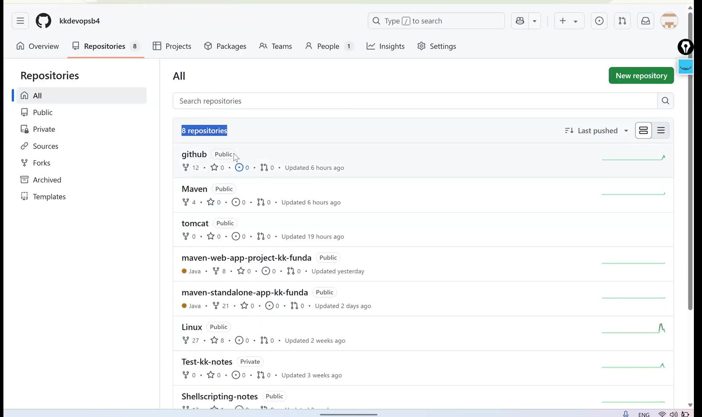
In order to download the repositories we have to execute the following shell script in our local computer
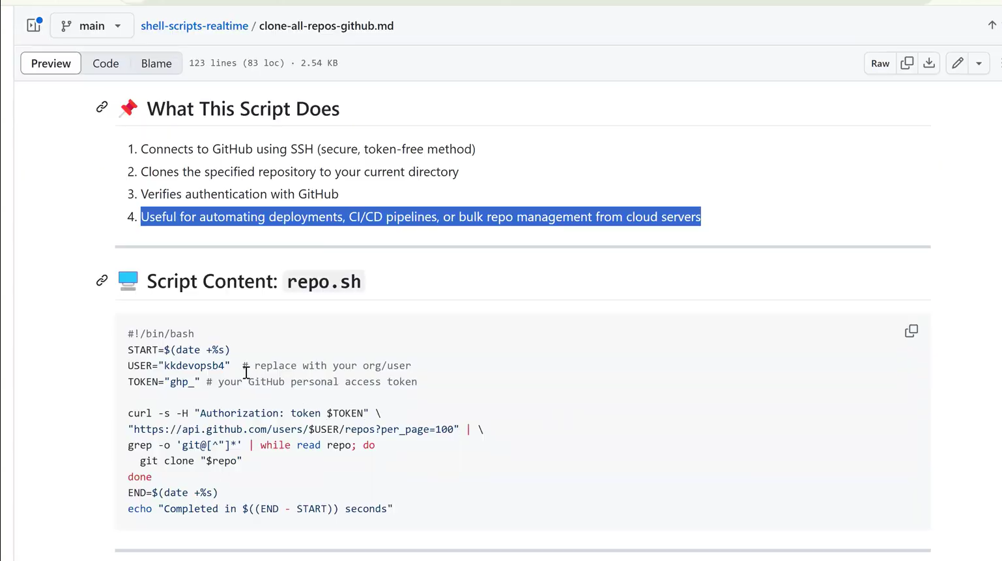

Copy the script and debug it in our local computer’s shell script
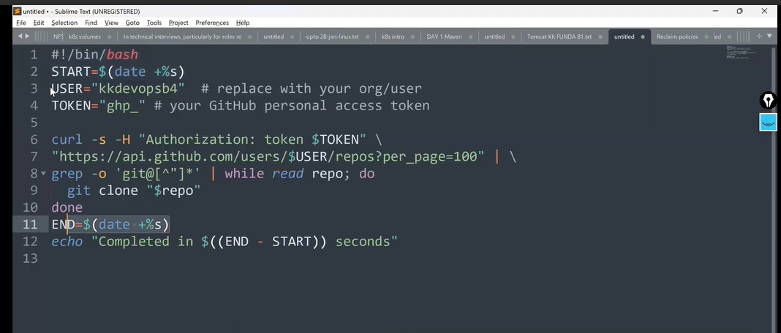
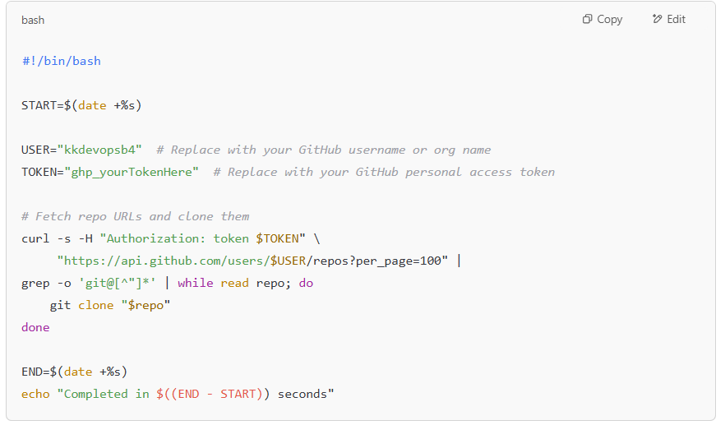

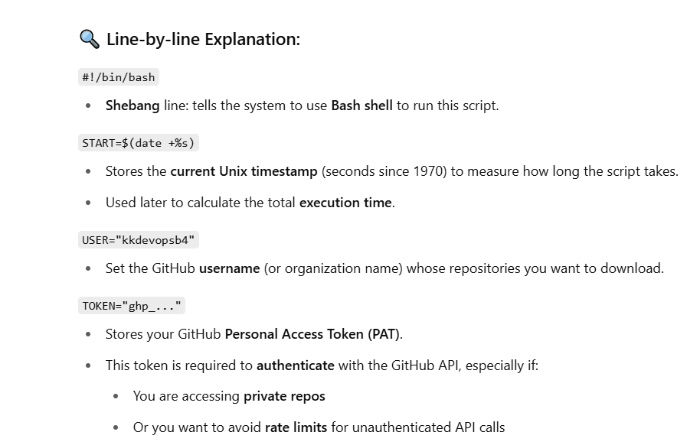
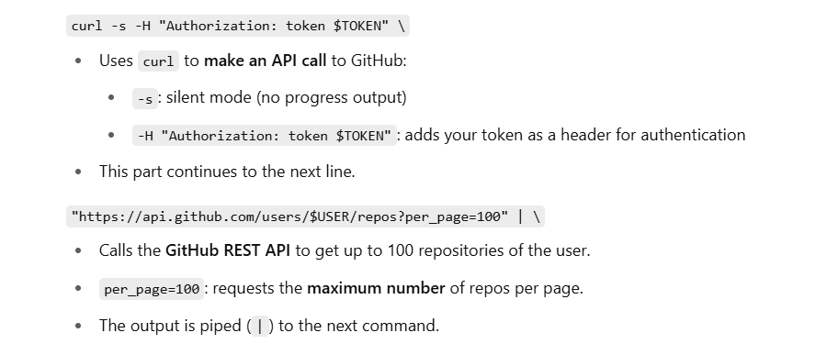
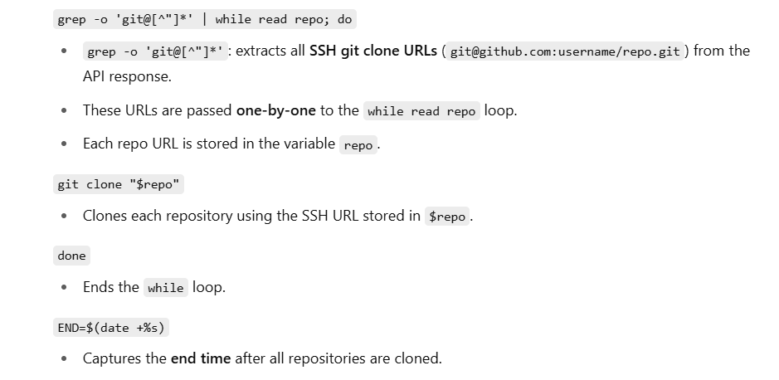
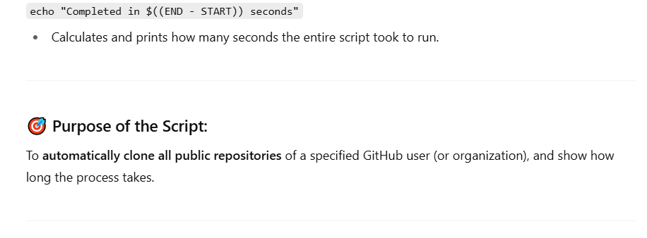
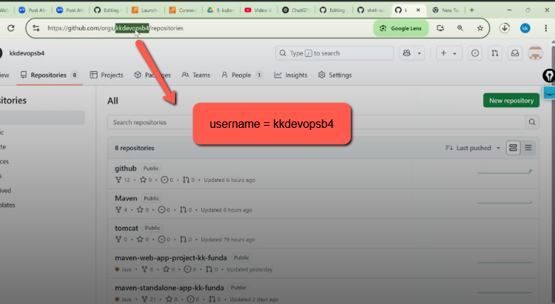
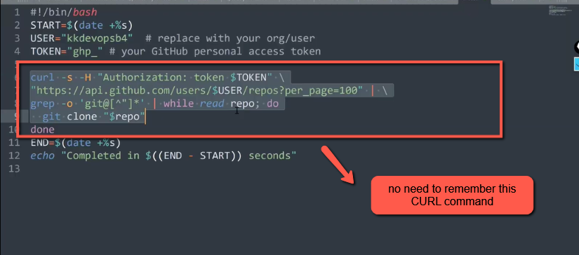

Next Task is to list all the branches associated with each Repository consider this task as an assignment
Let’s talk about the main topic. So far, we learned how to get the source code from a GitHub repo and turn it into .war, .jar, or .ear files using Maven.
Now, we need to deploy these files to the Tomcat server and run them using Tomcat commands.
Lets learn about Tomcat server Theory , Installation setup In the next class we will dump or deploy the artifact in to Tomcat server
We can deploy the Artifact in to Tomcat server using multiple ways
a) using CURL command
b) using Manual Method
Important Point ::
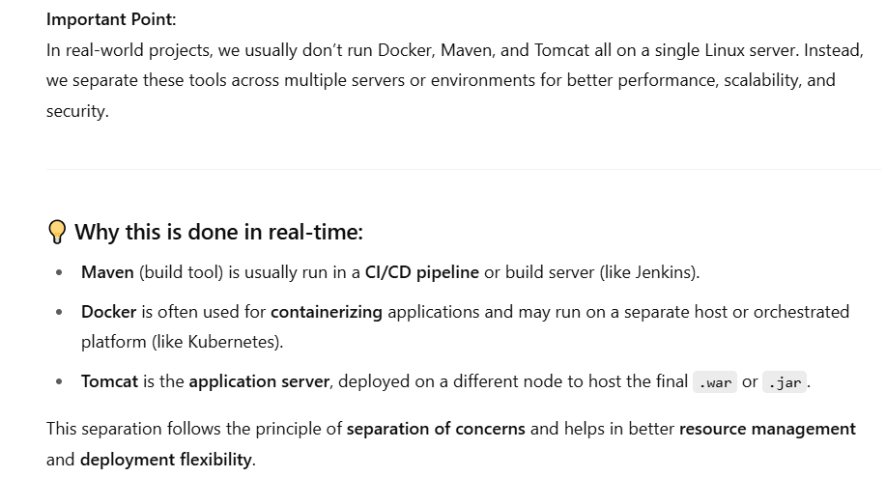

Tomcat Server :

Tomcat Server [Application Server]

Definition:
Tomcat or Apache Tomcat is an open-source web container used to deploy and run Java-based web applications. It was developed by the Apache Software Foundation (ASF).

Types of Application Servers
- Apache Tomcat (or Tomcat):
→ We can deploy only .war files, not .ear files.
- JBoss / WildFly:
→ Version 1.x to 7.x is called JBoss
→ Version 8.x and above is known as WildFly
- WebSphere Application Server – developed by IBM
- WebLogic – developed by Oracle
- GlassFish – an open-source application server
------------------------------------------------------------------------------------------------------------------------------------------------------------------------------------------------------------------------------------------

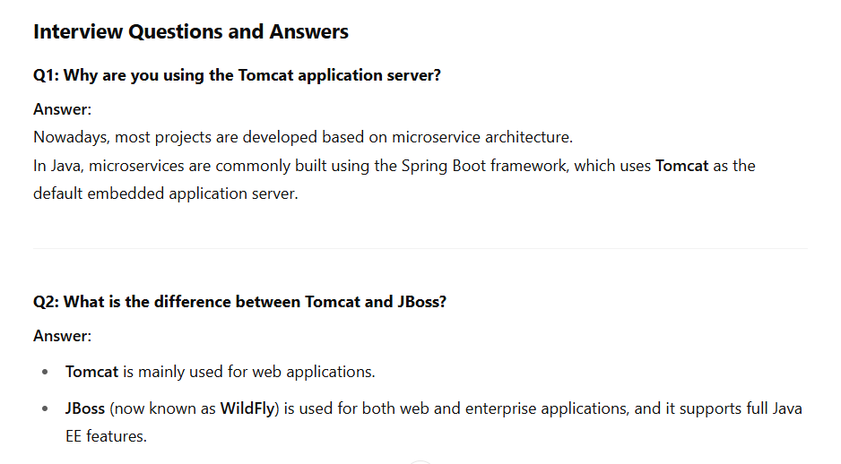

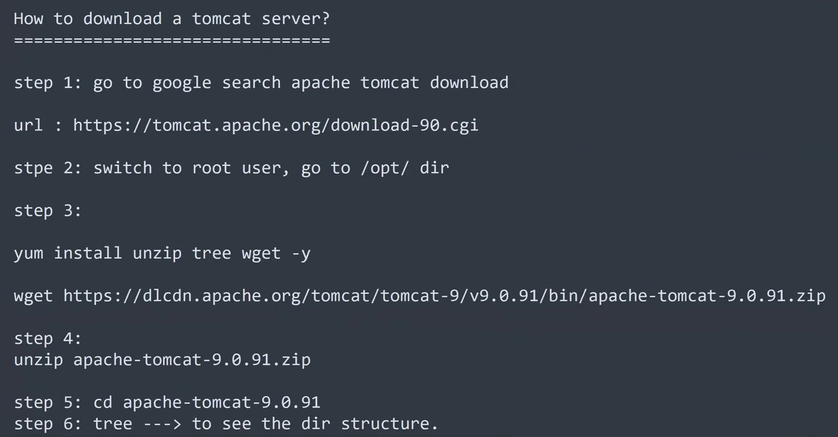
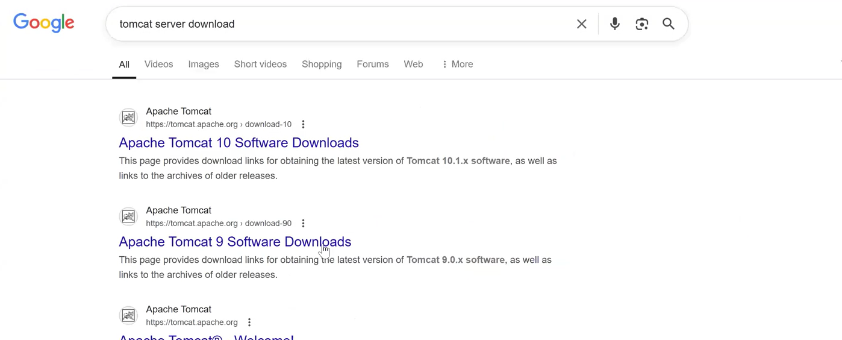
Click on the second url
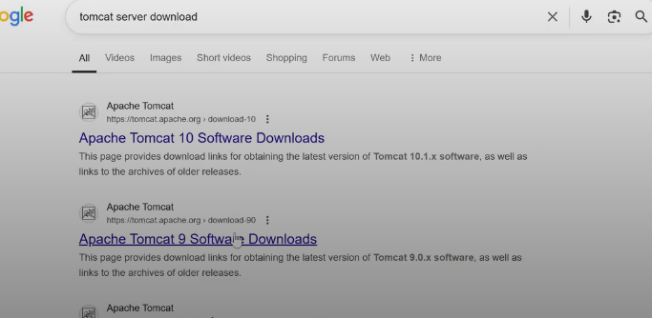

Scroll down you will find the version 9.0.104
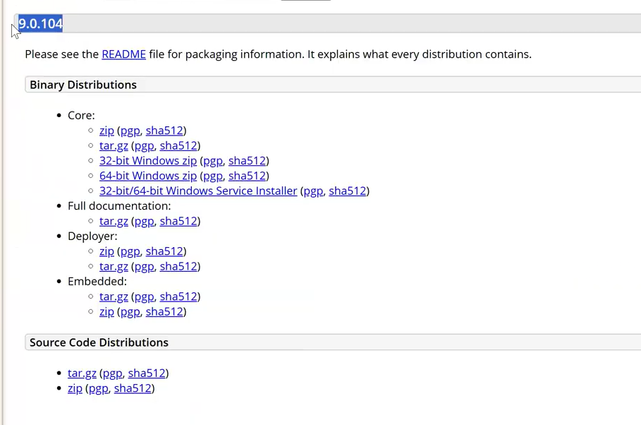
Right click on Zip folder and copy the link address
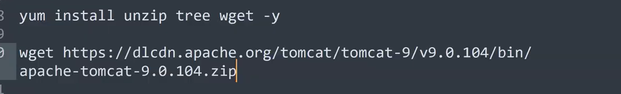

Before installing Tomcat we have to install the below applications
